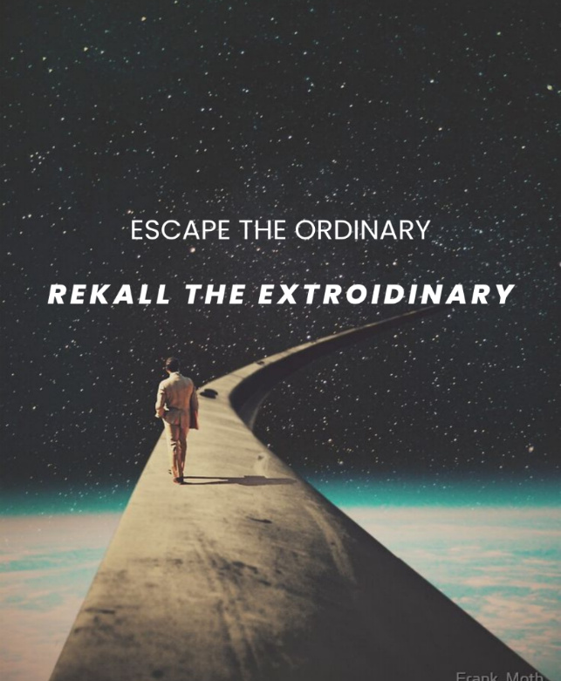

Escape the Ordinary. Rekall the Extraordinary.
Would you like to ski the Swiss Alps or duck hunt in the bayou, but you’re snowed under with work? Dreaming of a tropical island or an undersea adventure, but can’t float the bill? Have you always wanted to climb the mountains of Mars, but now you’re over the hill?
Then come to Rekall—where the world (and beyond) is just a virtual experience away.
Rekall specializes in ultra-realistic virtual vacations, so vivid and immersive, they feel like the real thing—all from the comfort of your own home. Whether it’s a sunset cruise through the rings of Saturn, a pyramid expedition in ancient Egypt, or a romantic stroll through the streets of Venice—we bring your dream vacation to life.
No plane tickets. No packing. No limits.
Why Virtual Travel?
Flights cost a fortune. Luggage goes missing. Tourist traps are packed. And don’t forget the time off work, the dog sitter, the babysitter, and someone to water your plants. With Rekall, you skip the hassle and still enjoy a five-star getaway—for a fraction of the cost.
Accessible Adventures for All
Mobility issues? Fear of flying? Social anxiety? No problem. Our virtual experiences are made for everyone—no matter your age, ability, or travel history. All you need is a VR headset and a sense of adventure.
At Rekall, Every Trip Is First Class
Enjoy a private cabin on your space shuttle, a luxury suite with a view, and all the iconic sights—customized just for you. Every experience includes two weeks’ worth of vivid, lifelike memories. Want more time? No problem. Speak with your Rekall ambassador to extend your journey. Customizations start at just $9.99.
Ego Trips & Extended Adventures
What’s the one thing that never changes when you travel? You. Same personality, different place. But with Rekall VR, you can become someone else entirely. Our Ego Trip feature lets you choose an alternate identity. Be a treasure hunter, a celebrity, or a secret agent.
Packages start at just $99, with premium options available for interstellar journeys, historical immersions, and fully personalized dreamscapes.
Extended journeys and Ego Trips are part of our Premium Package Subscriptions, starting at $199.
Don’t let life pass you by. Call Rekall—for the memory of a lifetime.

